



Scrum Master

Ms. Meera Rose Mathew

Assistant Professor  
Department of Computer Applications

Nurturenest

20INMCA509 - Mini Project 2

Ashlymol Thomas

AJC20MCA-I020

INMCA2020-25 S9

https://github.com/IntAshly/MiniProject_2.git

ashlymolthomas2025@mca.ajce.in

UML DIAGRAMS

Use Case Diagram

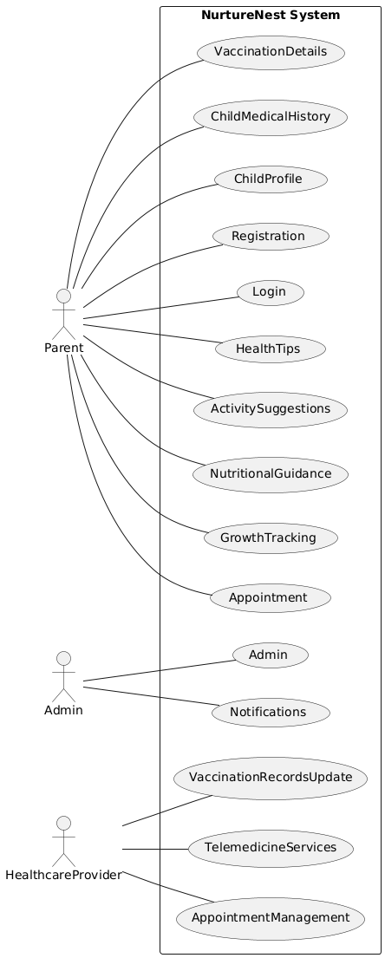

Sequence Diagram

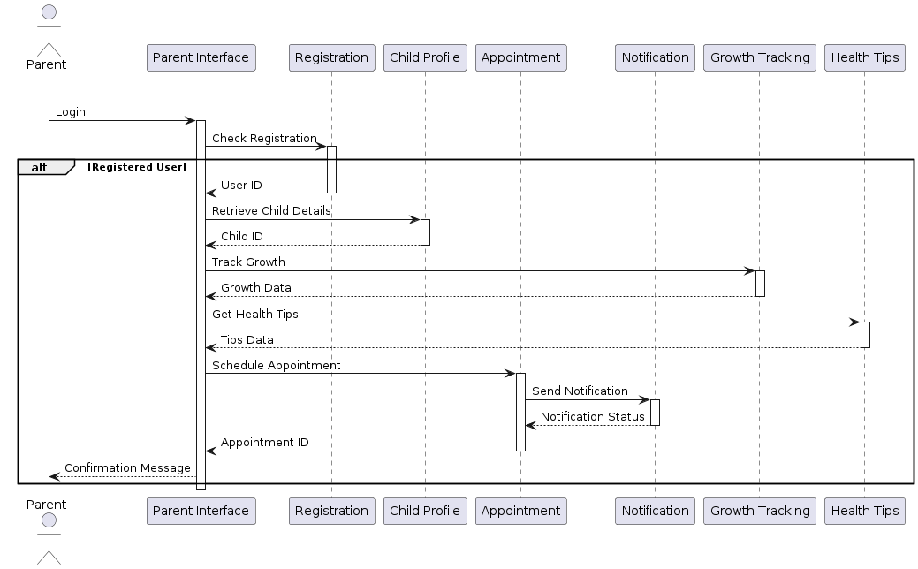

Class Diagram

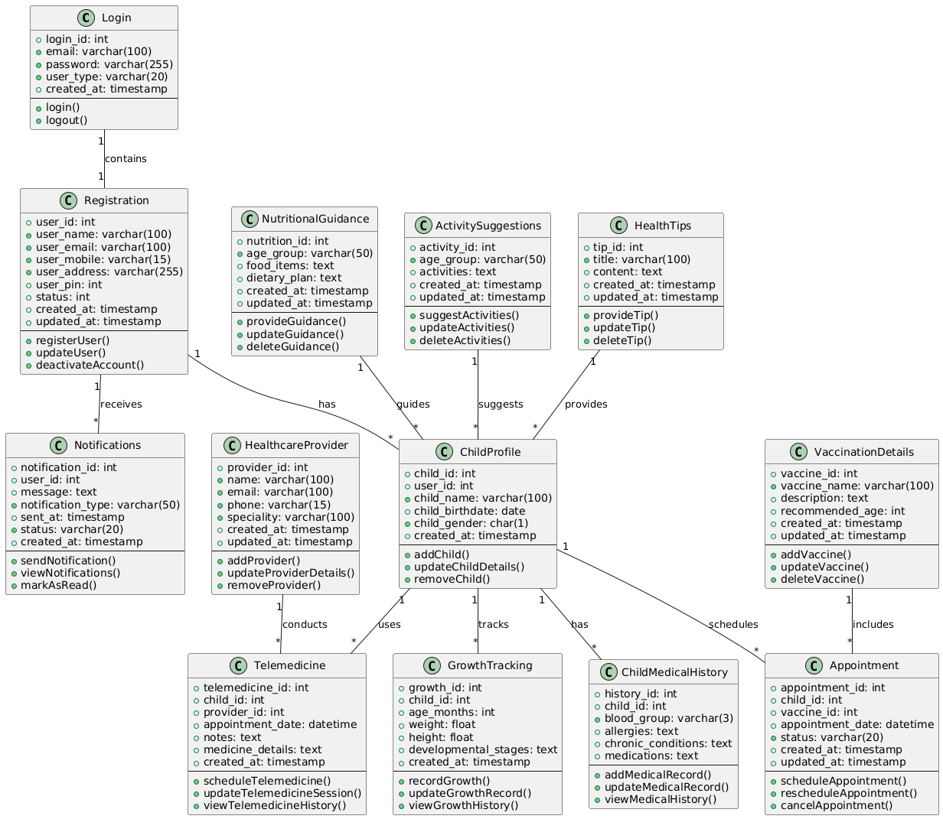

Object Diagram

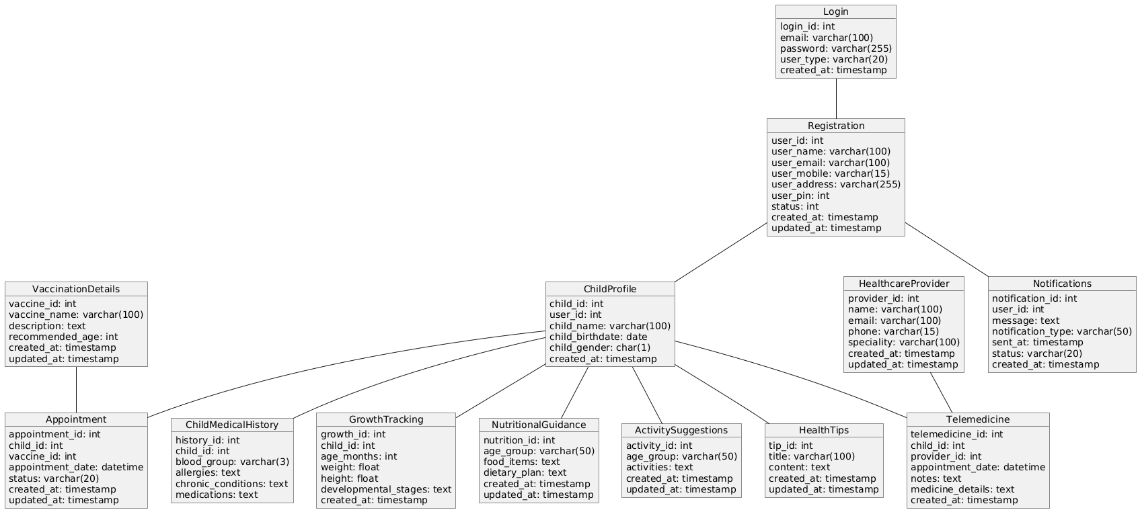

Activity Diagram

